Basic Decision Structures
Scenario Context:
Digitization of Slice & Dice Pizza Palace Section: BCS-1D you are hired as a Software Engineer to digitize the operations of 'Slice & Dice Pizza Palace'. The manager wants a console-based application to take orders, apply promotions, and print final receipts

Question 1:
The cashier needs to select the correct base size of pizza for the client. Write a C program segment that asks the cashier to select a size option (1 for small, 2 for Medium, 3 for Large). Store their input as an integer. Use a decision-making structure to verify if the input is valid (1, 2, or 3). If the input is valid, print the size they chose (e.g., 'Medium size selected'). If they enter an incorrect option, print the error warning: 'Invalid size.' and skip any further calculations.

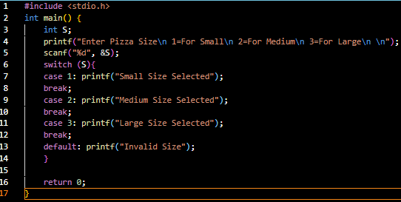

Question 2:
A small-sized pizza has a base price of $8. The shop owner wants to make sure cashiers are always advising clients about deals. Write a program that prompts the cashier for the number of pizzas the customer wants. If the customer is buying more than 1 pizza, display the promotional reminder on the screen: 'Check our multi-pizza deals.' Otherwise, calculate the total price directly at $8 per pizza, and output: 'Your total is $8.'

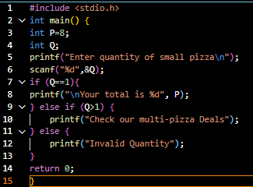

Question 3:
To attract bulk orders, Slice & Dice Palace implements an absolute pricing matrix for their small pizzas: 1 pizza costs $8; a combo of 2 pizzas costs $15; and a package of 3 pizzas costs $21. Write a program that asks the cashier to input the customer's desired pizza quantity (limited to 1, 2, or 3). Using a conditional ladder, compute the base cost according to this pricing policy and print the final package total along with the quantity.
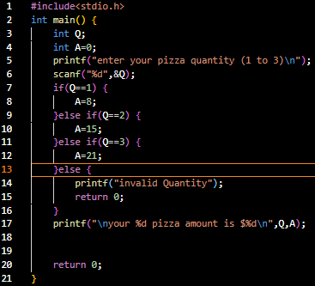

Question 4:
Customers can choose their crust to suit their preference. Each crust selection has a distinct pricing addition: Regular crust costs $0, thin crust adds $1, and Stuffed crust adds $2. Write a program that asks the cashier to enter the current total cost of the order. Then, prompt for the crust type choice (1 for regular, 2 for Thin, 3 for Stuffed). Use conditional branches to add the appropriate surcharge to the total and print the new updated bill total.

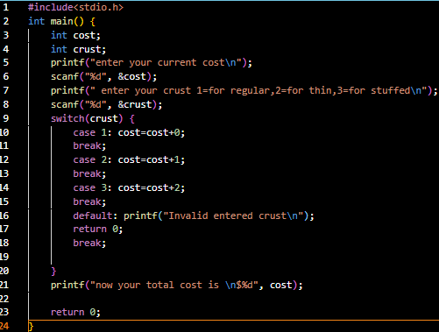

Question 5:
Extra cheese is a popular option that carries a fixed preparation fee of $1.50. Write a program that prompts the cashier for the current order total, then asks: 'Do you want extra cheese (Y/N)?'. Check the character input. If the cashier enters 'Y' or 'y', add $1.50 to the current total cost and print the updated total. If they enter 'N' or 'n', keep the total unchanged. Handle any invalid characters with a polite warning.

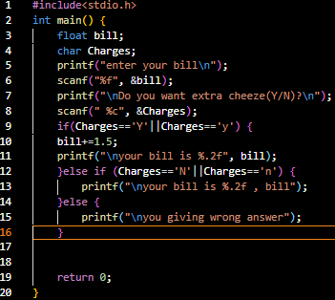

Question 6:
To drive traffic during the slow lunch-hour dip, the shop offers a special 10% discount between 11:00 AM and 2:00 PM (11 to 14 in 24-hour time). Write a program that reads the current total bill and the current time of day as an integer hour (0-23). Using logical comparisons, check if the hour falls within the promo window [11, 14] inclusive. If it is, deduct 10% from the total and print the discounted total. If not, print the original bill with no discounts.

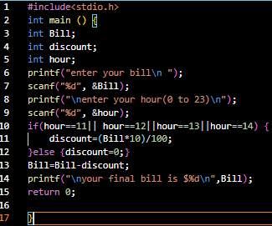

Question 7:
The program asks for the bill total and student ID status. If the customer has a student ID, it subtracts $2.00 from the total. After this, it uses a completely separate if statement to check if the bill is negative (regardless of whether a discount was applied) and adjusts it to $0.00 ifneeded. This makes the program more robust as it protects ALL customers from negative bills, not just students

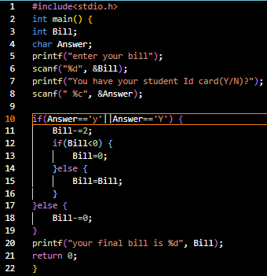

Question 8:
The shop is running a promotional giveaway to encourage premium combos: If a customer orders exactly 3 pizzas and selects the Stuffed Crust option, they qualify for a free side dish. Write a C program segment that reads the number of pizzas and the crust type selection (3 for Stuffed). If both conditions are met simultaneously using a compound logical operator, print: 'You get free garlic bread!'. Otherwise, print: 'Thank you for your order!'

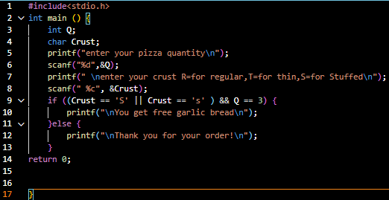

Question 9:
The store handles both pick-up orders and deliveries. A home delivery option adds a logistics and fuel surcharge of $3.00 to the bill. Write a program that inputs the order total, and then asks: 'Fulfillment Option (1. Pickup, 2. Delivery)'. Use a decision structure. If '2' is chosen, add $3.00 to the total. If '1' is chosen, add nothing. Calculate and output the final total cost of the order.

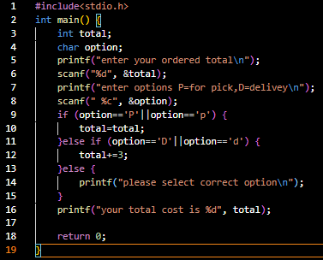

Question 10:
Integrate all the rules from Questions 1 to 9 into a single complete C program. The program must sequentially: 1. Input and validate the pizza size and count. 2. Apply the dynamic base pricing discount package. 3. Request crust type and cheese choice, adding relevant fees. 4. Prompt for the current hour and apply the 10% Happy Hour discount if appropriate. 5. Deduct the $2 student discount if they present an ID. 6. Evaluate the free garlic bread bonus eligibility. 7. Add delivery fees if chosen. 8. Print a beautifully clean, structured invoice with itemized charges and the final total cost.
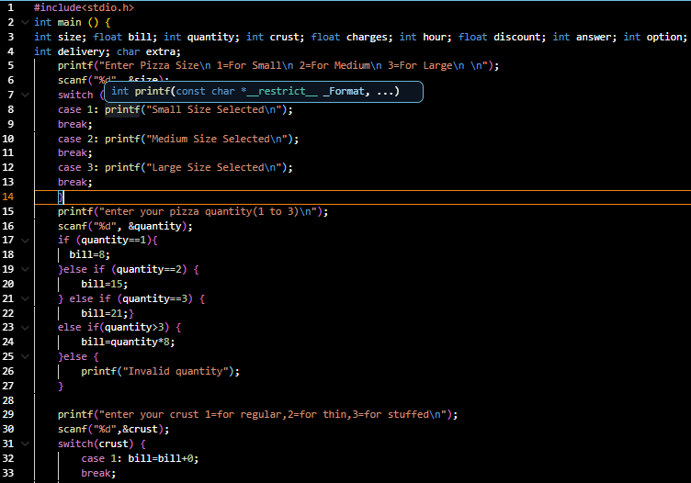

Countinue on next page
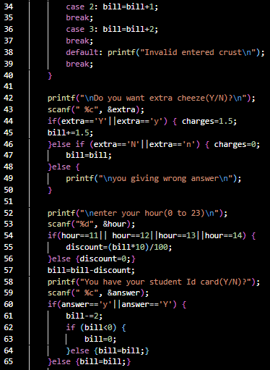

Countinue on next page
